Guidelines For Application for Vendor Registration
- Application for Vendor Registration portal of BYPL shall be operational from January to October month of every year for submitting the vendor’s credentials.
- Application for Vendor Registration portal shall be closed between November and December month of every year for assessment of credentials submitted by vendors.
- List of registered vendors shall be published on vendor registration portal before 30th January of every year.
- Vendor Registration Portal is supported on following Web Browsers:
4.1. Internet Explorer 8 and above
4.2. Mozilla Firefox 44.0 and above
4.3. Chrome 48.0.2564 & above
- Use https://www.bsesdelhi.com/web/bypl/bypl-tenders to access Vendor Registration Portal.
- Go to Vendor Registration.
- After log in, vendors need to submit information / documents in General, Business, Financial, Tax & Documents screens of Vendor Registration portal.
- Fill up entire details. Filling the (*) marked fields are Mandatory.
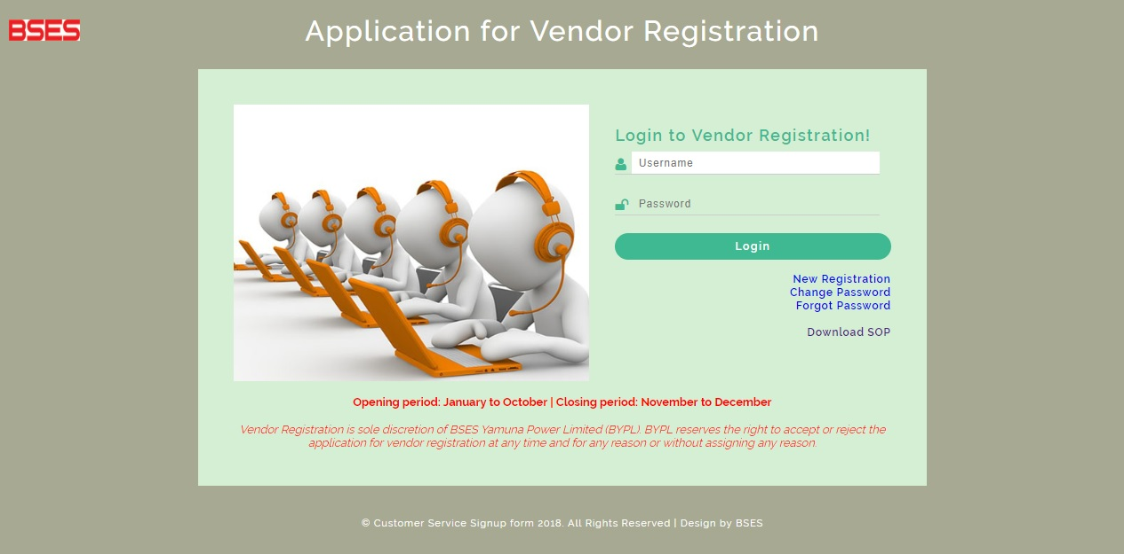

Application for Vendor Registration Home page

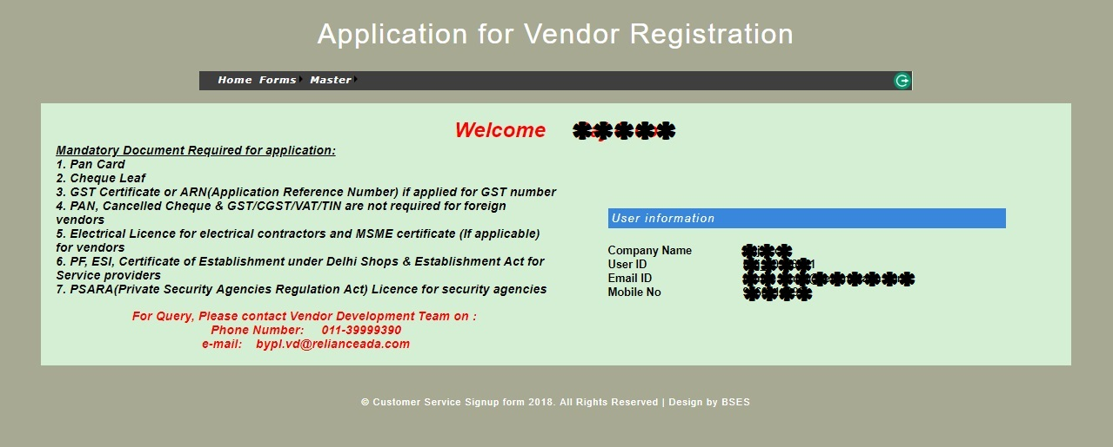

- Go to Forms and select General details.

General Details Screen
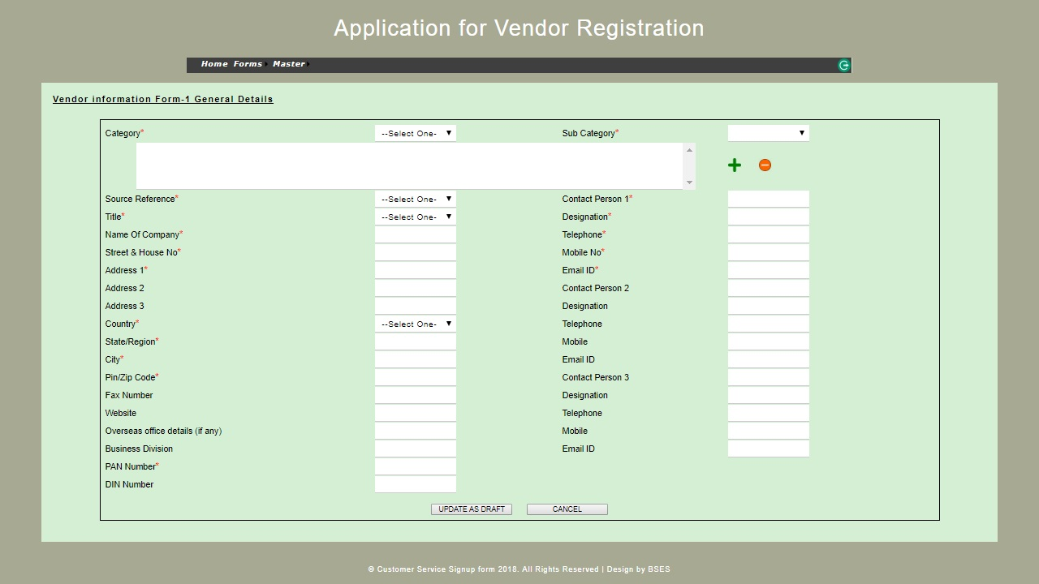

- Go to Forms and select Business details.

Business Details Screen
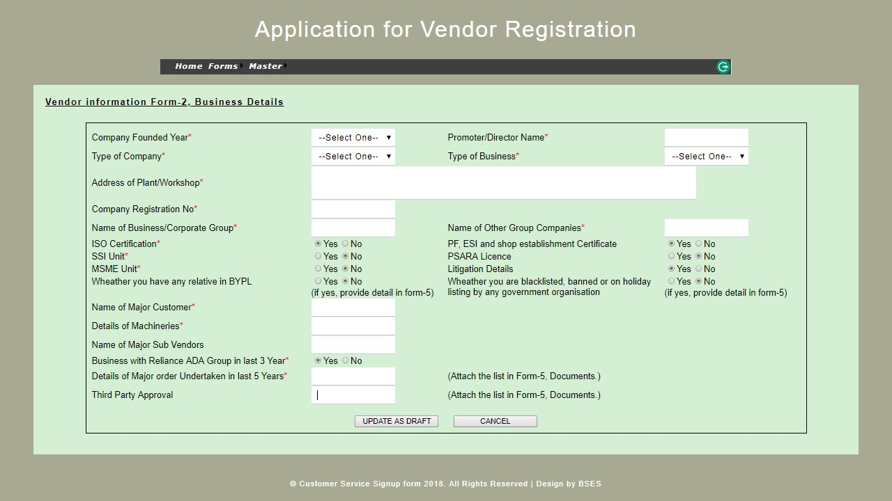

- Go to Forms and select Financial details.
- Financial details: If you have IFSC code, select Yes and write that in the field IFSC code.
Note: If you’re a foreign vendor, no bank details required.
Note: It is important to put entire Account Number including preceding zeros if any.

Financial Details Screen
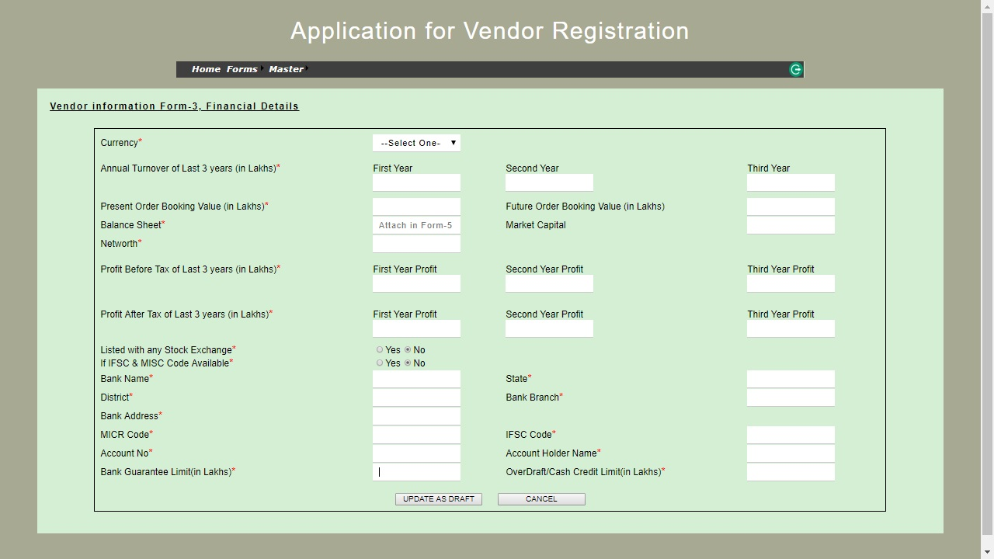

- Go to Forms and select Tax details.

Tax details Screen
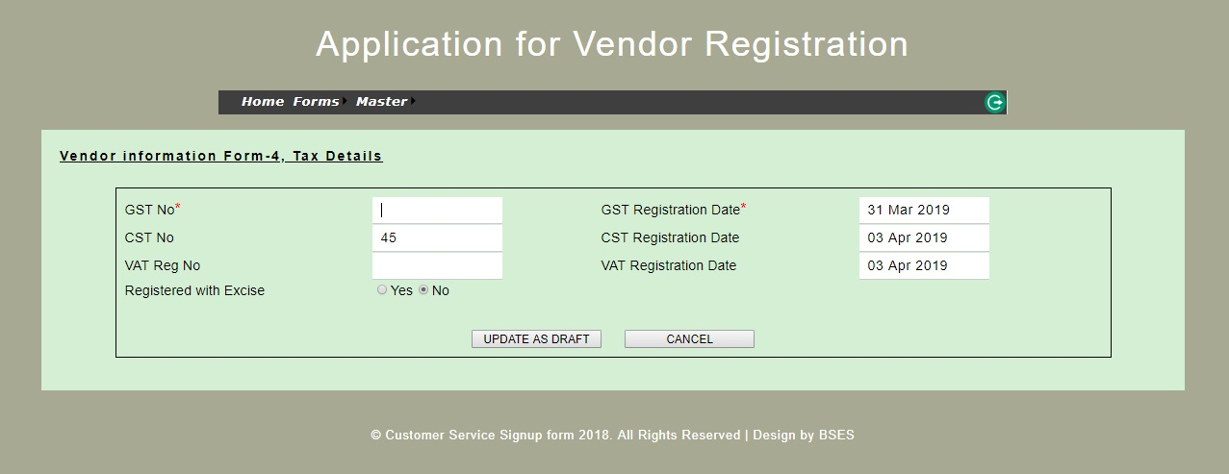

- Go to Forms and select Document.
- Upload the documents as per list of documents.
Documents Screen
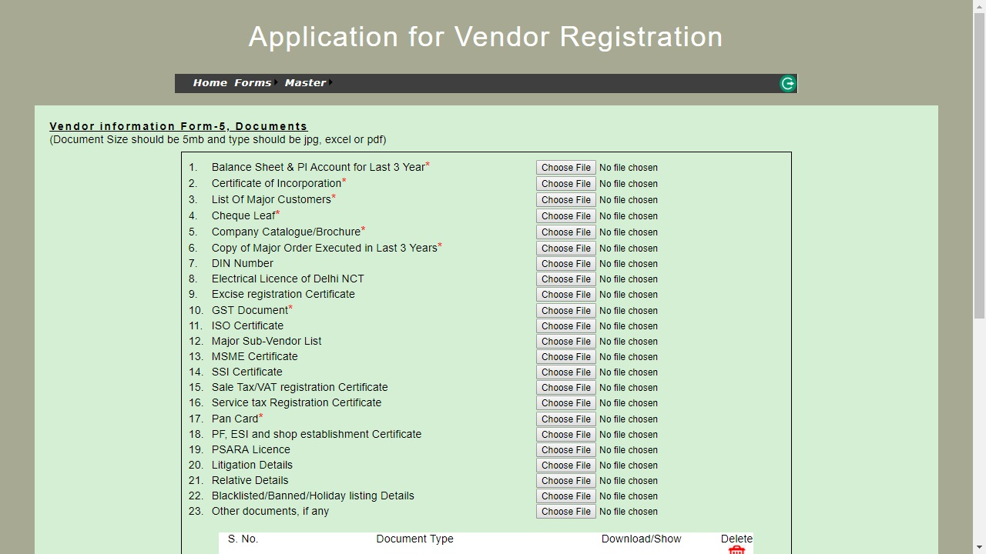

- Save & Submit the Application for Vendor Registration information.
- Vendor shall receive an email / SMS after submission of Application for Vendor Registration Form along with unique acknowledgment number.
- Vendor shall quote this acknowledge number for all future communications.
- In case of successful assessment, vendor will receive an e-mail from BYPL regarding further direction.
*****

